E-Commerce Operational Analysis and Preprocessing Pipeline
Prepared by: Swapnil Neupane
1. Project Overview
This project focuses on cleaning, analyzing, and preprocessing an international e-commerce transaction dataset. Instead of just looking at basic sales summaries, the goal of this pipeline is to transform raw, messy retail data into a clean, structured format ready for machine learning models (like clustering or anomaly detection). We will explore sales trends across time, hours of the day, geography, and top products before preparing our features for modeling.

2. Data Cleaning & Preprocessing
Before diving into the analysis, the raw dataset was cleaned to fix formatting errors, remove duplicate records, and handle missing information:
- Removing Duplicates: Dropped 5,268 exact duplicate rows to keep our transaction counts accurate.
- Handling Missing Customer IDs: Removed 135,080 rows that were missing a CustomerID. While these guest checkouts are fine for calculating total revenue, we cannot use them for tracking customer behavior or building machine learning profiles.
- Filtering Out Operations Errors: Cancelled orders and returns are recorded as negative values in the Quantity column. Additionally, some test items or giveaways have a UnitPrice of zero. To keep our data accurate, we filtered these out using:
After cleaning, we were left with a final dataset of 392,692 valid rows and zero missing values.

3. Feature Engineering
To get deeper insights from the raw data, we created a few new columns:
- Total Amount: Calculated as df['Quantity'] * df['UnitPrice'] to show the total money spent per row.
- Time Extraction: Converted the InvoiceDate text column into actual datetime objects to easily pull out the Year, Month, Hour, and day names (like Monday, Tuesday).
- Time Period Blocks: Grouped the 24-hour clock into four simple shifts to better understand shopping habits:
  - Morning: 00:00 – 11:59
  - Afternoon: 12:00 – 16:59
  - Evening: 17:00 – 20:59
  - Night: 21:00 – 23:59

4. Step-by-Step Exploratory Data Analysis (EDA)
The engineered dataset was evaluated across independent operational dimensions to map the real-world business realities of the firm:

A. Weekly Procurement Distribution
Aggregating revenue across weekdays revealed distinct purchasing habits. Total transaction revenue peaks heavily mid-week, specifically on Thursdays ($1,973,015.73), followed closely by Tuesdays ($1,697,733.80) and Wednesdays ($1,584,283.83). Volume drops significantly on Fridays and Sundays. Most notably, Saturdays register absolutely zero transactions. This completely flatline pattern confirms a strict Business-to-Business (B2B) procurement layout. Commercial retail managers purchase replenishment inventory early-to-mid week to guarantee physical shipping arrivals and clear logistics before local retail consumers sweep store shelves over the weekend.
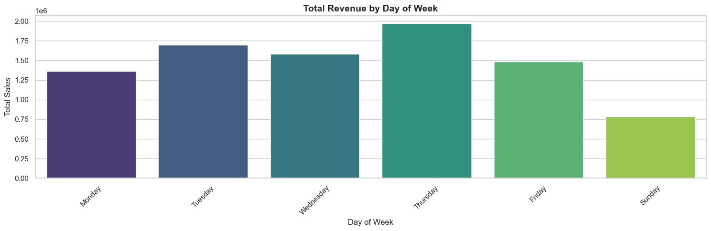

B. Intraday Commercial Shift Analysis
Hourly continuous tracking showcases zero transactions occurring between midnight and 06:00. Orders surge dramatically from 07:00 onward, hitting a massive single peak within the engineered Afternoon shift ($4,965,352.65), completely outperforming Morning ($3,515,898.78) and Evening sales ($405,957.46). This proves that wholesale ordering is strictly tied to standard corporate office hours when buying agents are active at their desks, rather than the nocturnal shopping patterns typical of individual retail e-commerce users.
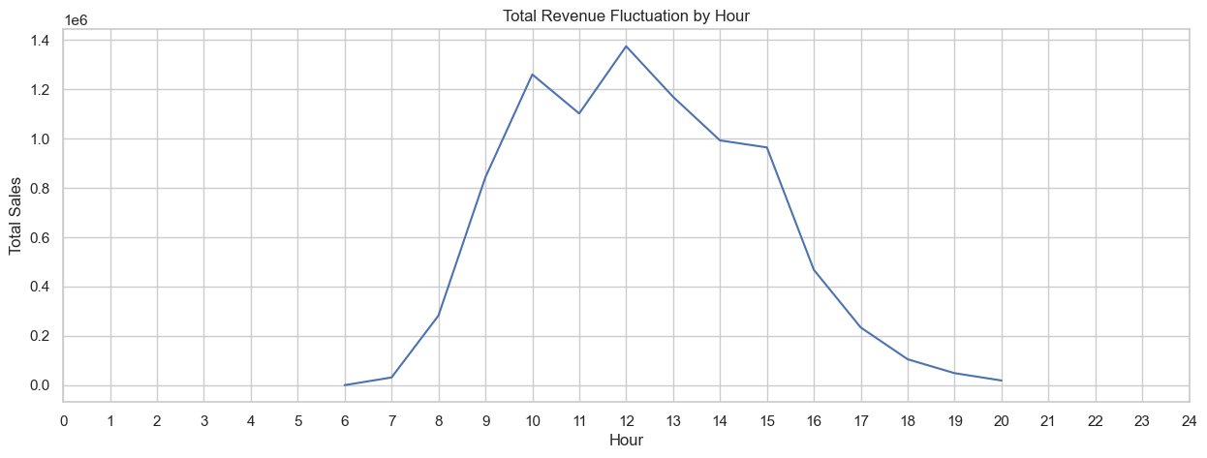
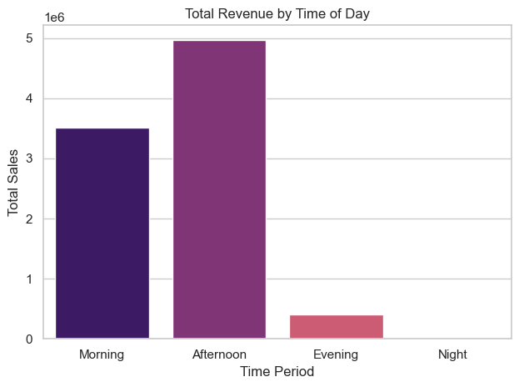

C. Geographic Market Allocations
Analyzing international source tracking verifies that while operations span multiple global borders, financial security relies heavily on a dominant domestic sector. The United Kingdom anchors the entire operation, driving over 80% of global revenue. Isolating non-UK territories reveals a tightly integrated regional block: EIRE (Ireland), Netherlands, Germany, and France form the core export channels, indicating high international operational efficiency within European border partners.
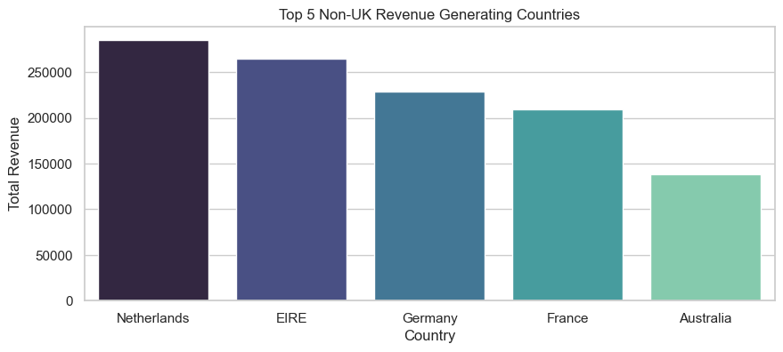

D. Inventory Concentration Performance
Evaluating item descriptions by financial weight proves that the catalog conforms to a stark retail Pareto principle. A highly concentrated minority of high-velocity stock listings, led by items like the "White Hanging Heart T-Light Holder", command a massive share of absolute transaction frequency and revenue volume, demonstrating their critical nature to supply chain maintenance.
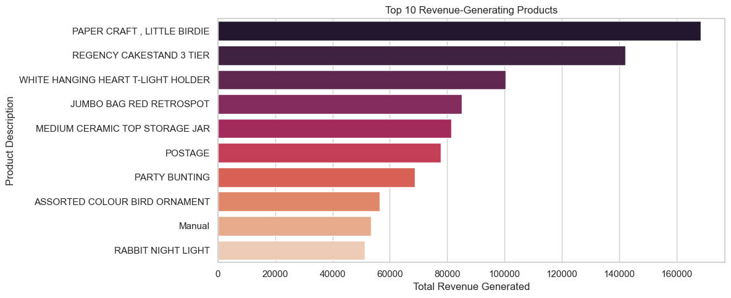

5. Machine Learning Preprocessing Pipeline
To prepare our data for machine learning models, we executed two key steps:

A. One-Hot Encoding for Categories
Models cannot read text strings like "Thursday" or "Afternoon." We avoided Label Encoding (assigning numbers like 1, 2, 3), because models mistakenly assume a higher number means "greater value." Instead, we used One-Hot Encoding via pd.get_dummies() to convert these text categories into clean 0 and 1 binary switches.

B. Feature Standardization (Scaling)
Our numerical columns have completely different ranges. Quantity values are small numbers, while Total Amount can be in the thousands. To stop columns with larger numbers from skewing our machine learning models, we used Scikit-Learn’s StandardScaler to scale Quantity, UnitPrice, and Total Amount so they all share a mean of 0 and a standard deviation of 1.

6. Exporting the Final Data
To wrap up our data preparation phase, we dropped all unscaled columns, raw text descriptions, and ID columns that math models can't read.
We saved our work into a clean CSV files so we don't have to re-run our entire notebook next time:
- cleaned_ml_features.csv – The pure numeric matrix $X$ ready for our models.

7. Conclusions & Strategic Recommendations
Based on our data pipeline findings, here are four practical business strategies:
- Optimize Warehouse Staffing: Schedule more fulfillment workers on Mondays, Tuesdays, and Thursdays to handle the mid-week ordering spikes. Reduce staff on Fridays and completely close on Saturdays.
- Target Digital Marketing: Run promotional campaigns and inventory emails between 11:00 AM and 3:00 PM, which is the high-conversion window when business buyers are actively ordering.
- Expand International Sales: Focus marketing efforts on established nearby European hubs like Ireland, Germany, and France to sustainably scale business outside the UK.
- Protect Core Inventory: Keep an extra safety stock of high-demand flagship items (like top home decor items) to prevent running out of stock on items that drive the company's baseline profits.

